Chapter 18, Problem 49.

Use the Fourier transform method to obtain v_{o}(t) in the circuit of Fig. 18.51.

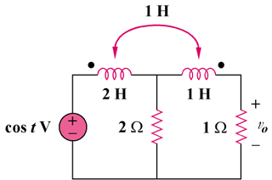

Figure 18.51
For Prob. 18.49.

